Immanuel Church
Feniscowles
Parish Policy for Vulnerable Adults
and
Persons at Risk
2019

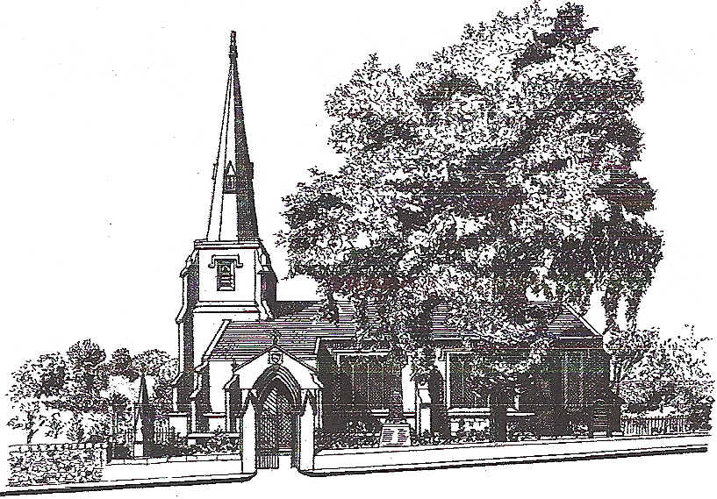

The Parish Church of Immanuel
Feniscowles and Pleasington

Special Note

This document has been developed around the Blackburn Diocesan Board of Education guidance notes for work with children and young persons and vulnerable adults.
The guidelines have been amended to reflect our parish Statement of Intent

Statement of intent for Immanuel Church Feniscowles.
We in the parish of Feniscowles, seek to provide a welcoming and attractive environment, which promotes the Christian faith, through mutual respect, care and responsibility, giving high priority to the Spiritual development of all the community.

A copy of the original BDBE will be kept for reference.

Register of Review

Accepted by the PCC | Date | Incumbent | Warden

Review of Child protection Policy
2012
2013
2014
2015
2016
2017
2018

The Parish of Immanuel Church Feniscowles
Vulnerable Adult Policy
Christian communities should be places where all people feel welcomed, respected and safe from abuse. The Church is particularly called by God to support those at the margins, those less powerful and those without a voice in our society. Our church respects the effort of its staff and volunteers, who may, by their efforts to support others become a person at risk. The Church can work towards creating a safe and non-discriminatory environment by being aware of some of the particular situations that create vulnerability. Issues, which need to be considered, include both the physical environment and the attitudes of all.

This policy only applies to those operating within Immanuel Church Feniscowles.
Our policy is to support all person(s) with whom we have contact or who support those within the community by following the guidelines to the best of our ability and to take what action is necessary within our powers to support those who may be at risk. Under our (PCC) duty of care it is our responsibility to recruit with care those who voluntary commitment brings them in close and regular contact with the Vulnerable or they themselves may be open to abuse.

The purpose of the Policy is to promote a code of practice for all who come in regular contact with vulnerable adults and to make sure that such work is undertaken to the highest standards possible. This will enable the parish not only to conform to the requirements of the law, but also enable all to live and work within a safe and caring Christian setting.

The Parish of IMMANUEL FENISCOWLES therefore commits itself to providing a safe and caring environment for all.

The Policy has been developed by following the Blackburn Diocesan Guidelines and the House of Bishop’s Policy Document Statement on safeguarding adults in the Church of England.

Identification of Persons
Guidelines for working with vulnerable adults
All volunteers who are official church volunteers should carry identification for their role and official records of their function are to be kept in the parish.
Where people are visiting residential homes, nursing homes, hospital or hospices, it is advisable to managers or staff should be pre-warned of the visit. Where people visit vulnerable people on their own, volunteers should plan their visit and keep a diary/record of the visit.

The following is a list of people who are likely to need registration under the policy:
• Those who visit residential homes for the elderly
• Those who take Communion to the sick in their home, institution or hospital
• Those who are involved in luncheon clubs
• Those who visit people living in sheltered accommodation
• Those who undertake pastoral visiting in the parish
• Those who offer transport services
• Those likely to come into regular contact on their own, e.g. Verger
Abstract from Bishops letter
Definitions
A Vulnerable Adult
Is a person aged 18 years or over
“who is or may be in need of community care services by reason of
mental or other disability, age or illness;
and
who is or may be unable to take care of him or herself, or unable to
protect him or herself against significant harm or exploitation”.
Ref Who Decides Lord Chancellors Department (1997)
Thus a vulnerable adult may be a person who:
_ Is elderly and frail
_ Has a mental disorder including dementia or a personality disorder
_ Has a physical or sensory disability
_ Has a learning disability
_ Has a severe physical illness
_ Is a substance misuser
_ Is an unpaid carer
_ Is homeless
_ Is in a period of temporary vulnerability caused by bereavement; trauma or separation.
Abstract From Bishops letter BDAC

The presence of a disability or age alone does not signify that an adult is
necessarily vulnerable i.e. unable to take care of themselves or unable to
protect themselves from abuse or exploitation.

Abuse
The term abuse can be subject to wide interpretation. For the purpose of the
application of this Policy the following definitions apply
“Abuse is a violation of an individual’s human and civil rights by any
other person or persons.”
No Secrets DoH (March 2000)
In giving substance to this definition consideration needs to be given to a
number of factors. Abuse may:
_ Consist of a single act or repeated acts
_ Be physical, verbal, psychological or emotional
_ Be an act of neglect or an omission to act
_ Occur when a vulnerable adult is persuaded to enter into a financial
arrangement or sexual relationship to which they have not, or could not
have, consented.
The above definitions have been copied from the City of Westminster NHS web site and are intended to guide the PCC of Immanuel Church Feniscowles.and are generally in line with the Bishops letter
Examples of Abuse
Abuse can take various forms:

Physical Abuse
This is the ill treatment of an adult, which may or may not cause physical injury. It includes, but is not limited to:
Hitting Slapping

Pushing Kicking
Forcing Restraining
Withholding or misuse of medication. Biting
Squeezing Suffocation
Drowning Killing

Emotional Abuse
This is the use of threats or fear to negate the vulnerable person’s independent wishes; it includes but is not limited to:
Lack of privacy/choice Denial of dignity
Made to feel worthless Lack of love or affection
Threats Humiliation
Blaming Controlling
Pressuring Coercion
Fear Ignoring the person
Verbal attitude
Deprivation of social contact/deliberate isolation

Financial Abuse / Legal Abuse
This is the wilful extortion or manipulation of vulnerable adults’ legal or civil rights including misappropriation of monies or goods; it may include but is not limited to:
Misuse of finances/lack of money Exploitation
Theft or fraudulent use of money Embezzlement
Misuse of property or possessions

Neglect
This is any pattern or behaviour by another person, which seriously impairs the individual; this can include but is not limited to:

- Failure to intervene in situations where there is danger to the vulnerable person or to others, particularly when a person lacks the mental capacity to assess risk
- Not giving personal care
- Withholding food, drink, light and clothing
- Deliberate withholding of aids such as hearing or mobility
- Restricting access to medical services
- Limiting choice
- Denial of social, religious, cultural contacts,
- Denial of contact with family
- Left alone unsupervised

Misuse of Medication
This may include but not be limited to:

- Withholding medication
- Deliberate poisoning
- Inappropriate use of medication

Sexual Abuse
Any sexual act carried out without the informed consent of a vulnerable adult is abuse. It includes contact and non-contact abuse.
Non-contact abuse may include but not be limited to:
- Sexual remarks and suggestions
- Introduction to indecent material
- Indecent exposure
- Teasing

Contact Abuse may include but not limited to:
- Indecent assault
- Touch
- Sexual intercourse
- Being forced to touch another person

Perpetrators of abuse may be:
- Relatives and other family members
- Neighbours
- Visitors
- Carers – informal/formal
- Professional staff
- Volunteers
- Other service users
- Care practitioners
- Strangers
- Clergy
- Professional church workers
- Church members
- Member of a community group such as a place of worship or social club
- People who deliberately exploit vulnerable people
- Members of church visiting teams

From time to time Organisations can and do abuse and cause harm by the way they conduct their day to day practice - churches and Christian groups need to be aware and sensitive to this.
Abstract from Bishops Letter

Person at Risk
A person at risk by a position of trust. Any person acting honourably, who visits a person on a singular person basis, may be considered a person at risk. If doubt exists, then two people should be present, one of which must comply with Immanuel Policy or be CRB cleared. The person in charge of the visit must be on the Immanuel register of Visiting Persons.

Who decides if a person is vulnerable?
Decisions on ‘vulnerability’ should be on a collective basis of which the Incumbent and the Vulnerable Persons Co-ordinator are the minimum team. Enquiries may seek information from Immanuel PCC or others persons within the community who may have knowledge of the situation/person(s). The team should take all reasonable measures within their capacity to indentify the vulnerable issues and advise accordingly.
Immanuel register of Visiting Persons.
Volunteers within Immanuel Church are well established within the community and are known by the PCC. Any person undertaking visits on behalf of Immanuel Church must be known to Incumbent or the PCC for a period of at least 3 years. New members to Immanuel Church who wish to volunteer for duties described within this policy must be CRB cleared before undertaking such work.
A register of persons acting under the name of Immanuel Church will be kept by Vicar/PiC/Incumbent and ratified by the PCC
What to do If Abuse is reported
Any accusations against person or persons operating under Immanuel Church Feniscowles Should be reported to the Vulnerable Persons Team and or Wardens immediately. Statements and actions should be recorded and reported to the PCC .
What to do if someone discloses abuse to you:
• Stay calm and try not to show shock
• Listen carefully rather than question directly
• Be sympathetic
• Be aware of the possibility that medical evidence might be needed

Tell the person that:
• They did the right thing by telling you
• You are treating this information seriously
• It was not their fault

DO NOT:
• Press the person for more details
• Stop someone who is freely recalling significant events as they may not tell you again
• Promise to keep secrets: explain that the information will be kept confidential, i.e. information will only be passed to those people who have “a need to know”
• Make promises that you cannot keep (such as “This will not happen to you again”)
• Contact the alleged abuser
• Be judgemental (e.g. “Why didn’t you run away?”)
• Pass on information to anyone who doesn’t have a “need to know” i.e. do not gossip

Recording
At the first opportunity make a note of the disclosure and date and time and sign your record.
You should aim to:
• Note what the people actually said, using their own words and phrases.
• Describe the circumstances in which the disclosure came about.
• Note the setting and anyone else who was there at the time.
• Record only factual information, DO NOT write your opinions.
• Use a pen or biro with black ink, so that the report can be photocopied.
• Be aware that your report will be required later as part of a legal action or
disciplinary procedure.
Abstract from Bishops Letter

Factors which may lead to abuse
Abuse can occur in any setting no matter where a person lives or where they are being cared for. Abuse can occur in residential or day care settings, in hospitals, in other people’s homes churches and other places previously assumed safe, and in public places.

Abuse is more likely to occur if the vulnerable adult:
- Rejects help
- Has a communication difficulty
- Has challenging behaviour
- Behaves in an unusual way
- Is not helpful or co-operative
- Is behaviourally disturbed or there are major changes in personality behaviour

Research has shown that mistreatment is more likely to occur if carers:
- Feel lonely or isolated and have no one to talk to
- Are under stress due to poor income or housing conditions
- Have other responsibilities i.e. work, family
- Are showing signs of physical or mental illness
- Are becoming dependant on alcohol or drugs
- Family relationships over the years have been poor
- Live where family violence is the norm

Other factors to look for include:
- Carer has their own problems
- Carer perceived the dependant adult as being deliberately awkward
- Vulnerable adult has few/no social contacts
- Vulnerable adult may have limited use of verbal communication or have preferred use of alternative communication systems

Abstract from Bishops Letter BDAC

How to Record abuse
Contact Immediately the
- Vicar/PiC/Incumbent,
- Vulnerable Persons Representative
- Wardens (see rear of Church Magazine for phone numbers)
Record as much information as you can on the form in Appendix 1. Only record what you know do not record guesses or elaboration. If you have been abused by someone who might be considered vulnerable, identify to the best of your ability the type of abuse. This information may be recalled by a Court of Law. Keep a copy and make sure it is dated.

Appendix 1 Form 1 Record of alleged ‘Statement of Abuse’

Form 1 - Statement of abuse
Date | Name of Person recording the information
Name of Person claiming abuse
Location of alleged abuse
Reason for the Visit
Diary and time line of events
Statement
Singned
Witness

[This pro-forma can be made to suit any format.]

Appendix 2 List of Approved Visitors

