Feniscowles
Immanuel Church
Parish Policy
for the
Protection of DATA
as required under the General Data Protection Act 2018

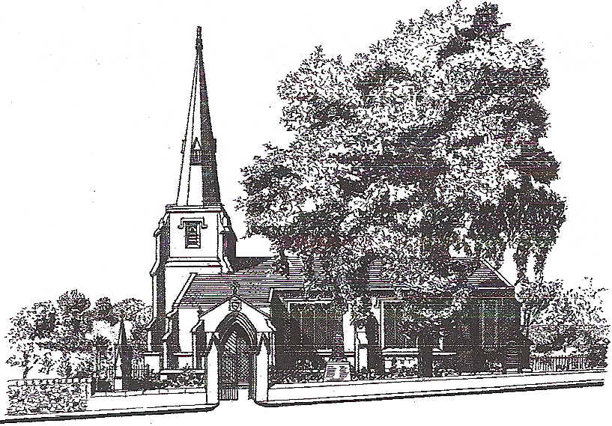

The Parish Church of Immanuel
Feniscowles and Pleasington
Parish Code 530107

Your privacy is important to Immanuel Church, as we need to communicate with all those who are officers or operate under the general banner of Feniscowles Immanuel we need your consent toto hold securely information to allow communication which is in line with UK law. As a result of change to the law we need you consent as to how we contact you.
Could you please fill the contact details below? -

Name…………………………………………………………….

Address…………………………………………………………..

…………………………………………………………………….

…………………………………. Post Code…………………….

e-mail aaddress…………………………………………………. Optional

Phone Number(s)…………………………………………………

……………………………………………………………………...Optional

For persons under the age of 13 a guardian or parent must sign on their behalf

By signing this form, you are consenting to Finiscowles Immanuel Parish Code 530107 using the above data for communication purposes.

I consent to Feniscowles Immanuel contacting me by post, e-mail or telephone. Please delete items as you wish.

I consent to Feniscowles Immanuel including my name and phone number on public contact list (Immanuel Church magazine)

Your details can be removed by informing the Chairman of the PCC
For magazine before the next print issue
For PCC at the AGM

Please return this DPP form to the Chairman of the PCC

