**IMMANUEL CHURCH**

**FENISCOWLES**

**ASBESTOS REGISTER**

Compiled on behalf of the PCC

2006

Reviewed

Nov 2008

Nov 2009 By the PCC and amended

Nov 2010 By the PCC and amended

Nov 2011 By the PCC and amended

Nov 2012 By the PCC and amended

Nov 2013 By the PCC and amended

Nov 2014 By the PCC and amended

Nov 2015 By the PCC and amended

Nov 2016 By the PCC and amended

Nov 2017 By the PCC and amended

Nov 2018 By the PCC and amended

Nov 2019 By the PCC and amended

Nov 2020 By the PCC and amended

1 Introduction.

This document is compiled under the guidance given in HSE publication INDG 223 “ Managing Asbestos in Premises” and HSE publication HSG 227 “ Comprehensive Guide to Managing Asbestos in Premises”. The Diocese of Blackburn have requested that all church buildings and properties be surveyed and a register held of known Asbestos Containing Substances (ACM) and were any doubt exists, then it shall be assumed to contain ACM’s until proved otherwise.

# 2 The Register

This register is sectionalised according to area labelled against the plans in Appendix 1. Each section contains a photograph of the known ACM displaying the warning label as fitted on the Type 1 survey. A photographic entry is also made of any suspected substance who’s composition is unknown.

Were a substance may give rise to concern but is known not to be of an ACM then a photographic entry is made stating what is believed to be the composition.

|  |  |  |  |
| --- | --- | --- | --- |
| Building | Location | Description | Date of Survey |
| Church | Boiler Room | Asbestos Cement Flue External | March 2006 |

Asbestos cement flue connected to Potterton Boiler. The boiler is the main heating appliance for the Church and is located in a well off from the vestry. Access to this area which acts as a plant room is via a locked door, a gate and finally step ladders. The flue extends outside the boiler house and rises vertically adjacent the external toilet. A label is affixed to the flue at this location giving clear indication to toilet user of the material. The joints of the flue are calked with fire cement. No attempt as been made to remove the calk and check for other ACM’s

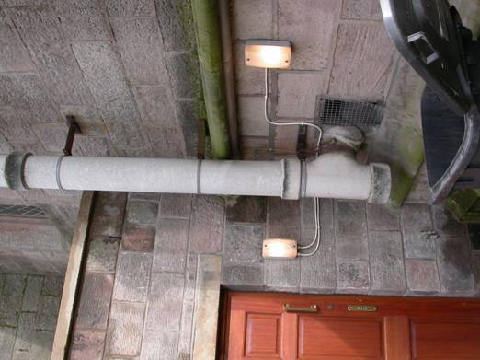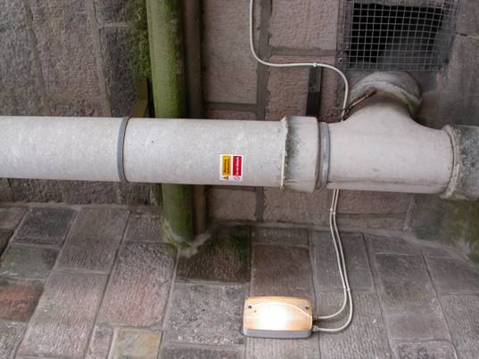

Church Boiler Flue showing exit position from boiler house and the affixed warning label March 2006 . See Plan 1 location 1

|  |  |  |  |
| --- | --- | --- | --- |
| Building | Location | Description | Date of Survey |
| Church | Boiler Room | Asbestos Cement Flue Internal | April 2006 |

Asbestos cement flue connected to Potterton Boiler. The boiler is the main heating appliance for the Church and is located in a well off from the vestry. Access to this area which acts as a plant room is via a locked door, a gate and finally step ladders. The flue extends outside the boiler house and rises vertically adjacent the external toilet. A label is affixed to the flue at the exit point giving clear indication to boiler maintenance personnel. The gaskets of the boiler are ceramic fibre. The boiler thermal casing as not been opened to inspect the refractory liner. No ACM anticipated

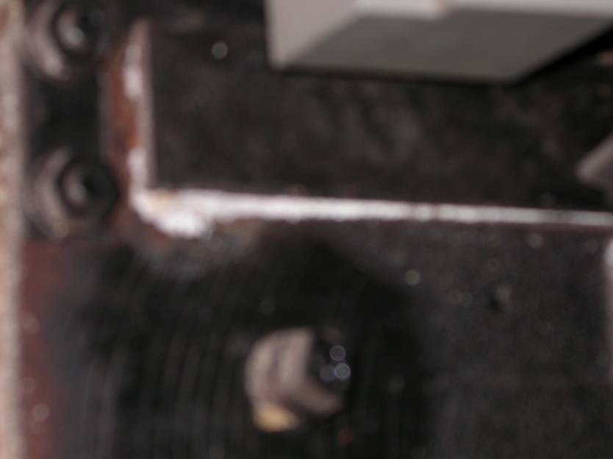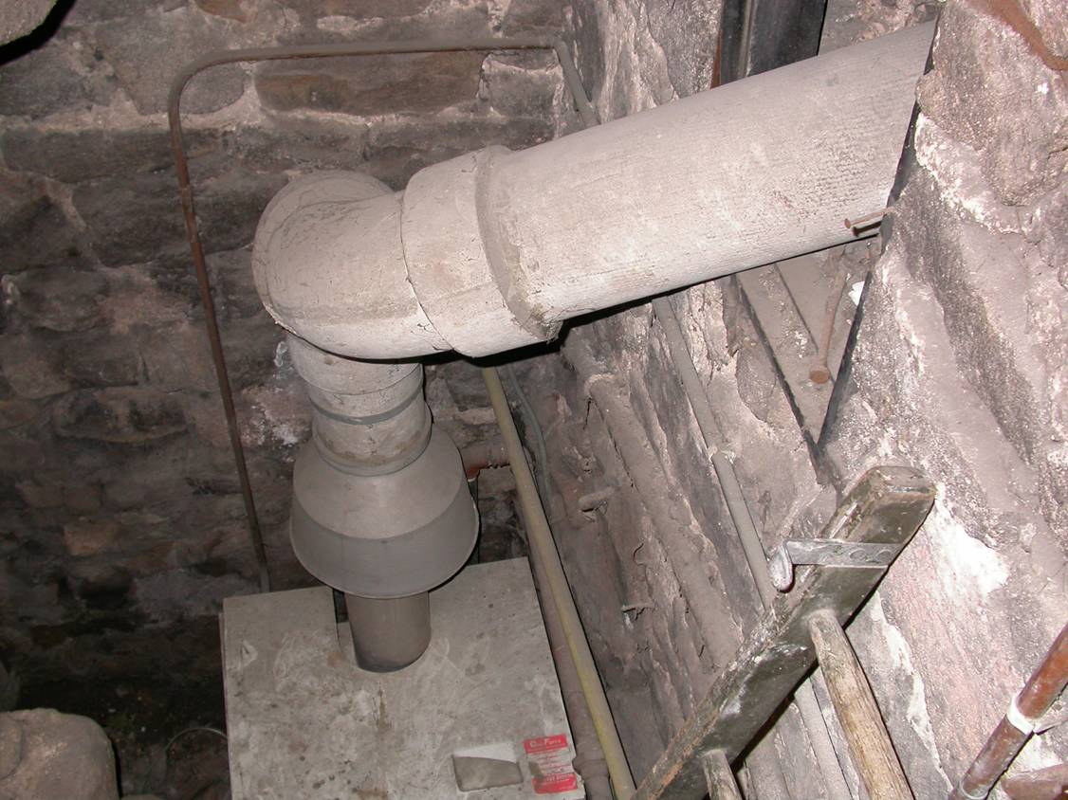

Ceramic Fibre Gaskets on Boiler Asbestos Cement Flue from Potterton Boiler

April 2006 . See Plan 1 location 1

|  |  |  |  |
| --- | --- | --- | --- |
| Building | Location | Description | Date of Survey |
| Church | Boiler Room | Asbestos Cement Flue Redundant Section | April 2006 |

Asbestos cement flue - Redundant. This redundant asbestos cement flue was connected to the a coke fired boiler and the remains are located in a well off from the vestry. Access to this area which acts as a plant room is via a locked door, a gate and finally step ladders. The flue extends into the masonry were it joins onto what is thought to be the original circa 1850 concealed chimney. A label is affixed to the flue at the terminal point giving clear indication to boiler maintenance personnel.

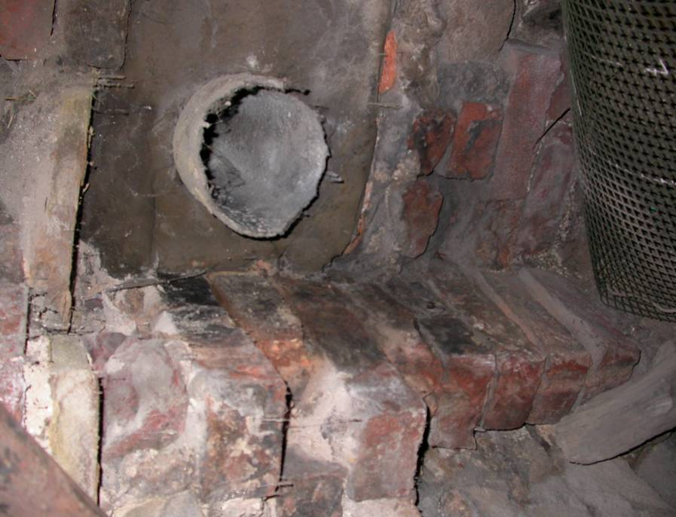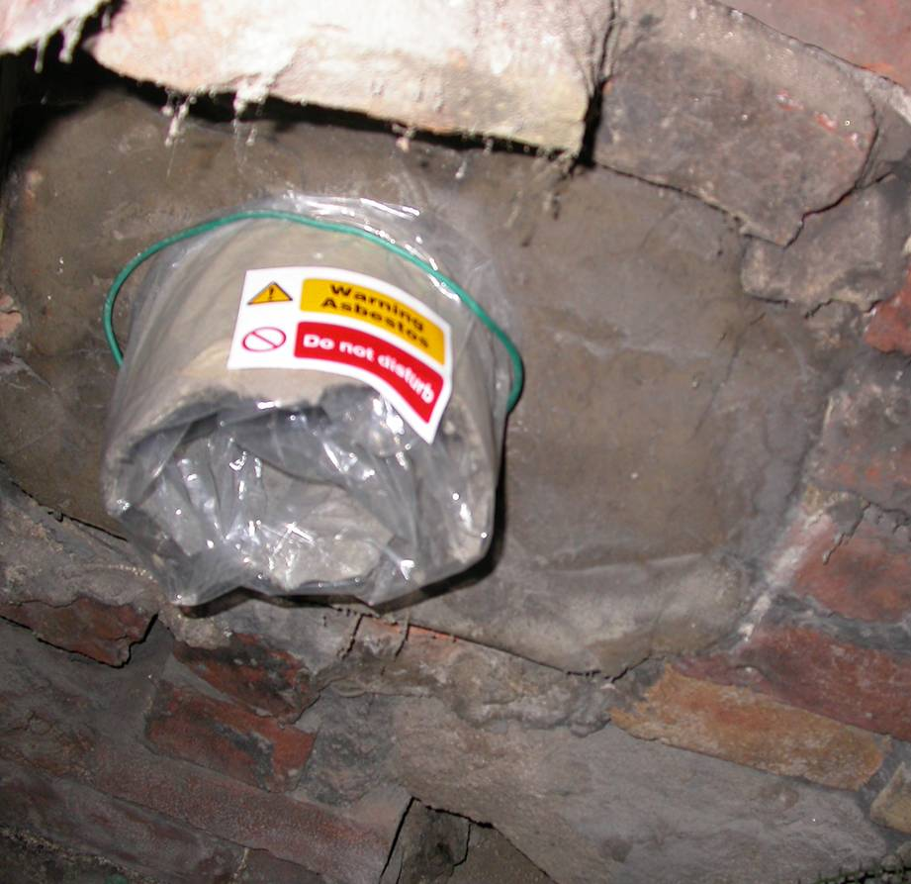

Redundant Asbestos Flue in poor condition. The flue spigot has been bagged and identified to prevent fibre release.

April 2006 . See Plan 1 location 1

|  |  |  |  |
| --- | --- | --- | --- |
| Building | Location | Description | Date of Survey |
| Church | Vestry Door | Non Asbestos Fire cladding | April 2006 |

Vestry Door – Plant Room. This door gives access to the boiler well and is within the vestry. The fire cladding is of a micasous cement material and no ACM is considered present.

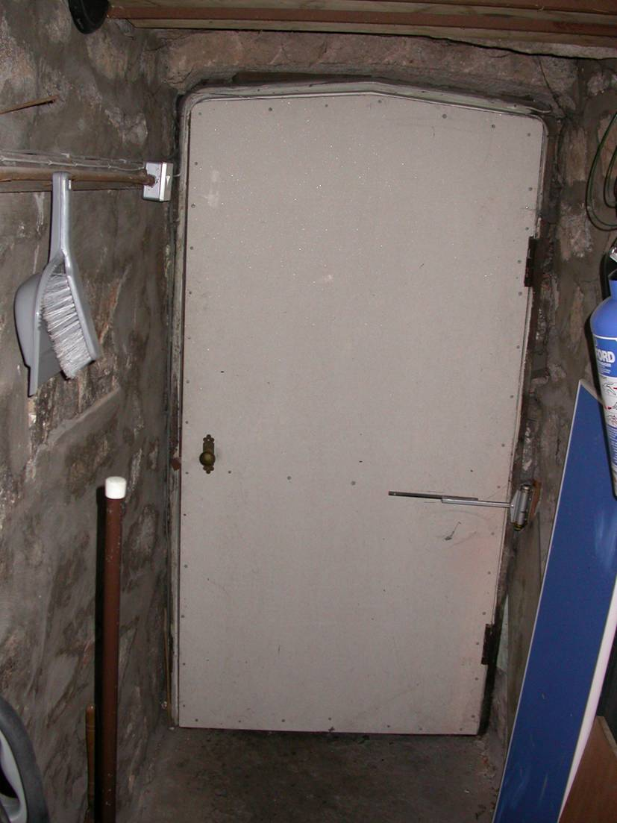

|  |  |  |  |
| --- | --- | --- | --- |
| Building | Location | Description | Date of Survey |
| Church | Balcony Underdrawing | Suspected Asbestos Cement cladding | April 2006 |

The balcony containing the Organ and additional side pews is underdrawn with cement board product suspected of being Asbestos Cement Sheet. The board is in good condition being well painted on the fair side and showing no sign of external damage. Label affixed as shown, no action required.

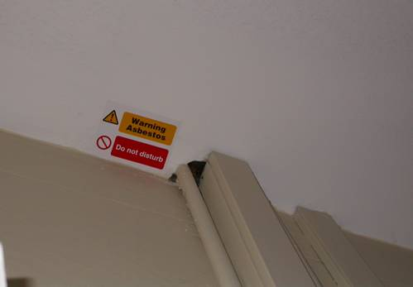

|  |  |  |  |
| --- | --- | --- | --- |
| Building | Location | Description | Date of Survey |
| Church | Body of Church Underdrawing to roof | Suspected Asbestos Cement cladding | April 2006 |

The roof of the main body of the church containing the pews and alter is underdrawn with cement board product similar to the balcony underdrawing and is suspected of being Asbestos Cement Sheet. The board is in good condition being well painted on the fair side and showing no sign of external damage. No label affixed, no action required.

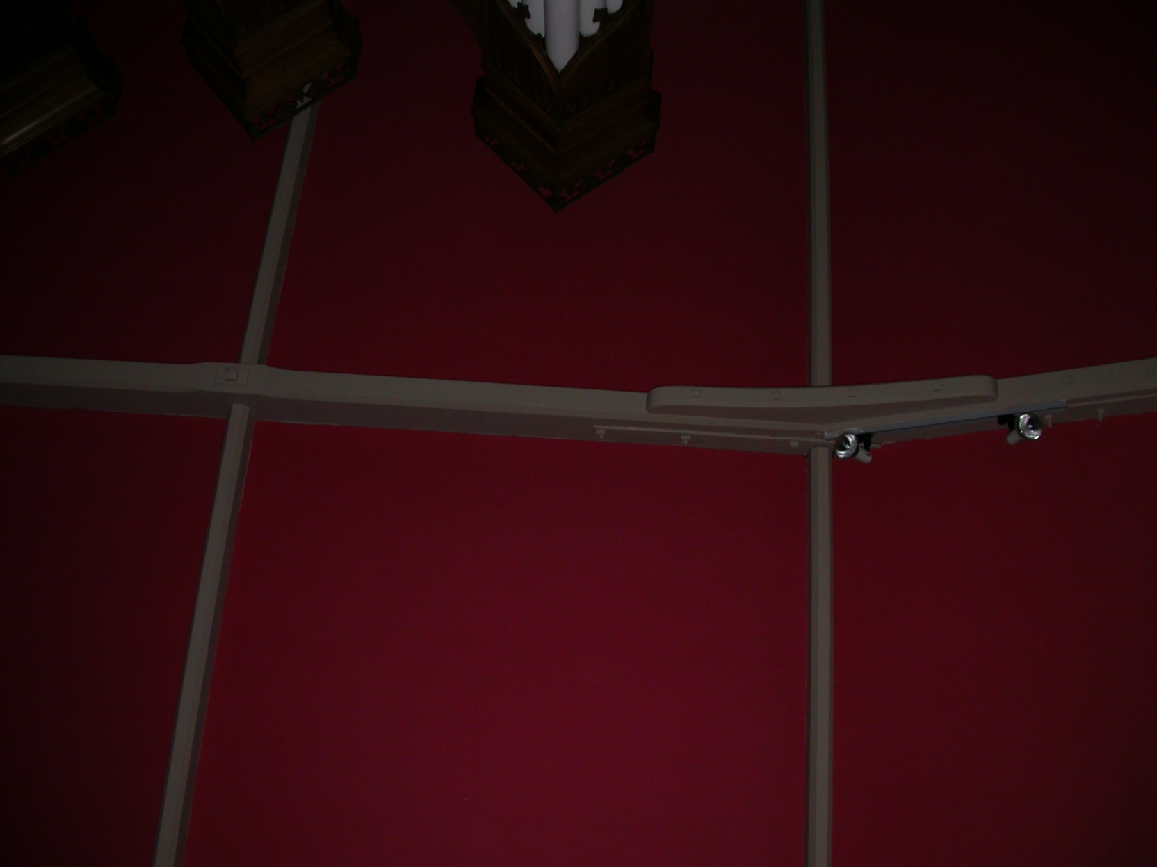

|  |  |  |  |
| --- | --- | --- | --- |
| Building | Location | Description | Date of Survey |
| Church Hall | Kitchen Door | Suspected Asbestos Cement Fire Cladding | April 2006 |

The door into the kitchen has been protected with a ‘cement board’ cladding. A small sample did not reveal fibres. However as the board origin and make up could not be identified, it is being considered as ACM for the time being. When a larger sample can be safely obtained an analysis will be undertaken to ascertain the material. A label has been affixed as shown

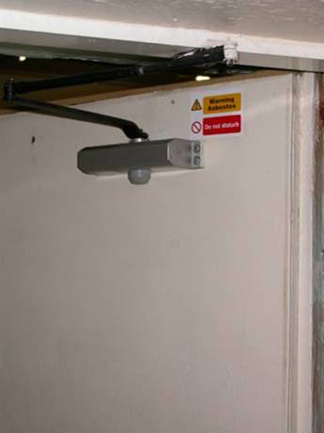

|  |  |  |  |
| --- | --- | --- | --- |
| Building | Location | Description | Date of Survey |
| Church Hall | Under Stairs Door | Fire Grade Plasterboard | April 2006 |

The door beneath the stairs in the lower hall has been protected with a fire grade plaster board cladding. This material is not suspected as being ACM as the date of install action was 1990’s.

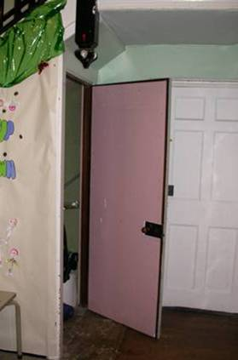

|  |  |  |  |
| --- | --- | --- | --- |
| Building | Location | Description | Date of Survey |
| Church Hall Upper Floor | Stage Partition ACM Found | Asbestos cement 5/16” (8mm) ‘Mill Board’ sheet heavily painted and attached with screws | Nov 2009 |

Examination of the remainder of the upper floor shown showed no asbestos products found. The ceiling is of plaster lathe. The exception being a section of partition located at the rear of a hardboard screen. User of the hall have been notified and a warning notice posted.

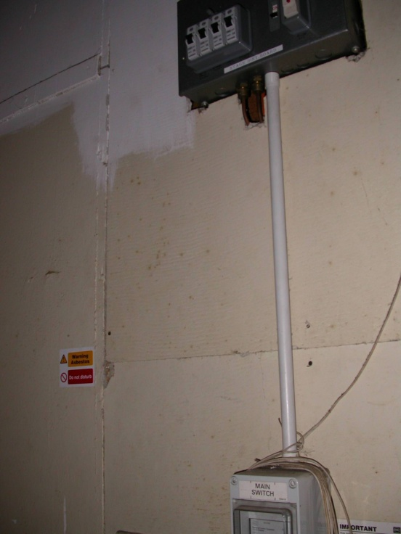

5/16” (8mm) ACM mill board screwed to wooden studded wall.

|  |  |  |  |
| --- | --- | --- | --- |
| Building | Location | Description | Date of Survey |
| Church Hall External | East Wall | Rainwater Pipes | April 2006 |

Examination of the rainwater pipes, (2 off) as shown in the photos are of bitumised asbestos cement product and are of a low risk. Due to frost cracking it is proposed that the pipes will be removed and replaced with PVC within 12 months.

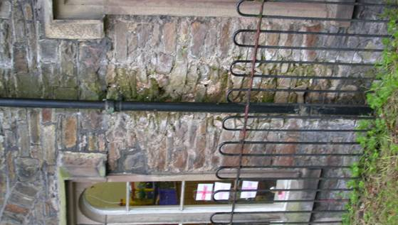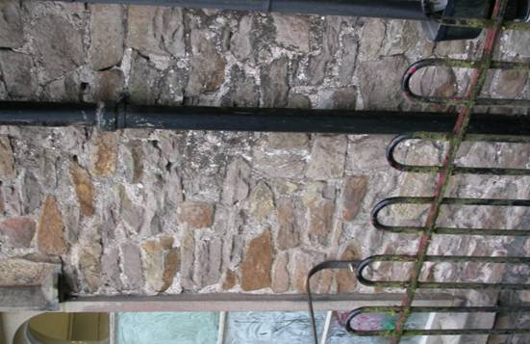

Pipe South on East Wall Pipe North on East Wall

Note

**These Pipes have now been removed and replaced with PVC rain water pipe in 2008**

# Appendix 1

1 Church Main Building

2 Church Boiler House

3 Church Hall Upper Floor

4 Church Hall External

5 Church Hall Lower Floor

1 Church Main Building and Balcony

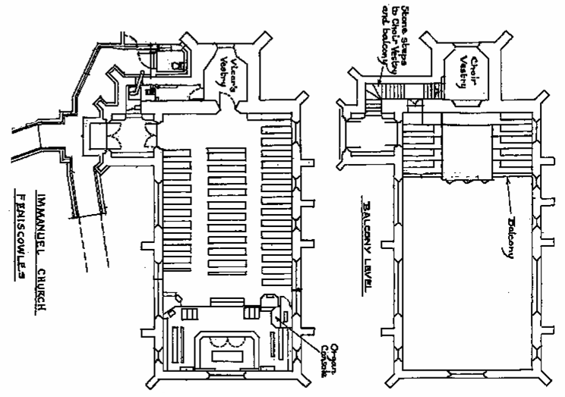

Suspected ACM Unerdrawing of balcony

Suspected ACM Unerdrawing Church Main Body

Asbestos Survey Immanuel Church April 2006

2 Church Boiler House

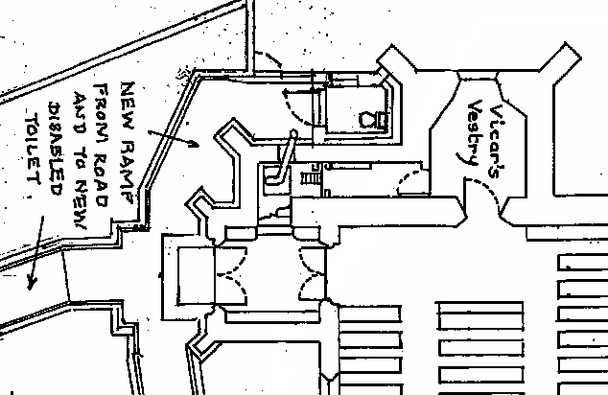

Asbestos Flue

Asbestos Flue REDUNDANT

Asbestos Survey Immanuel Church 2006

Micasous Cement Board to rear of Door

3 Church Hall Upper Floor



The above ACM was identified in Nov 2009

4 Church Hall External

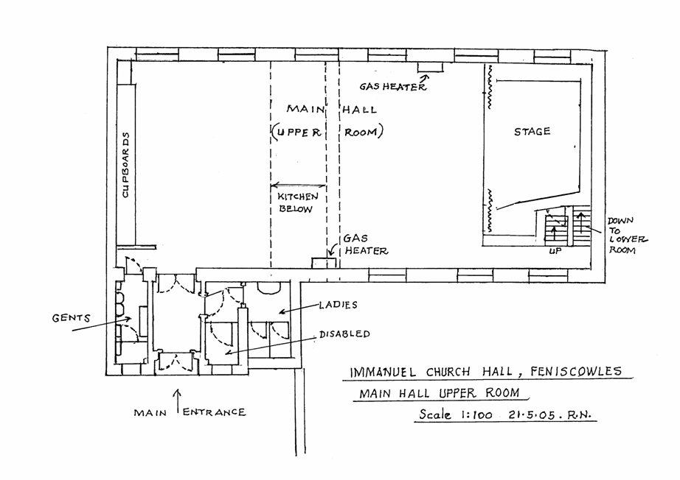

Church Hall External

ACM Rainwater Pipes

Pipes removed in 2008 and replaced with PVC rain water pipe.

5 Church Hall Lower Floor

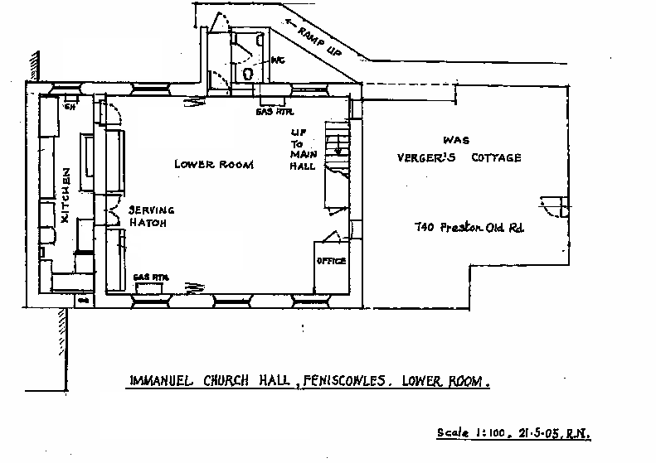

Fire Grade Plaster Board to rear of Door

Cement Board to rear of Door.

Considered to be ACM